Requirement Analysis, week 2

Purpose :

* Agreement between every parties
* Delimit the system
* Define the functionalities
* UI of system

Use Case is model proposed by UML to describe the requirement

## I Concept

### 1/Actor

An external entity that interacts with the system. It :

* Uses one or more functionalities of the system -> Primary actor
* Participate with the realisation of one or more functionalities -> Secondary actor
* Notation : Character shape

### 2/Use Case

Use Case is one functionality implemented by the system.

Notation : Ovale

### 3/The System

It is an abstraction of the system that we are implementing, it represents the boundaries of the system

Notation : Rectangle

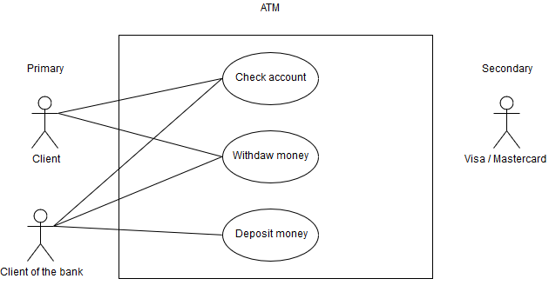

### 4/Inheritance between actors

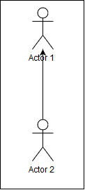b

Actor 1 inherits from Actor 2.

Actor 1 is a kind of Actor 2.

Inheritance can be used to factorize the common functionality.

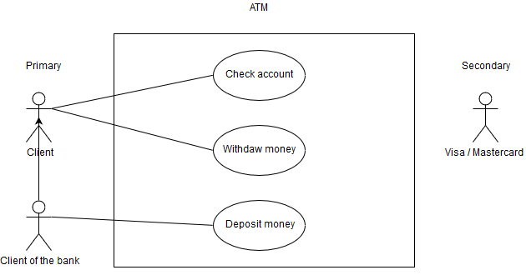

## II Advanced concepts

### 1/ Inclusion link between use cases

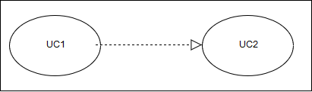

UC1 includes UC2, it contains the UC2

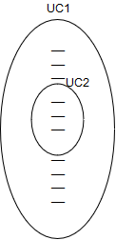

Includes happens EVERY TIME you use the included one.

When doing a UML always use a include from 2 Use Case included in 1 Use Case as minimum, to show comprehension and factorization

### 2/Extension link between use cases



The function UC1 optionaly extends the function UC2. It adds an additional behavior to UC2.

E.g :UC1 (print receipt) add an action to UC2 (withdraw money)

TD2 : Media Library System specification